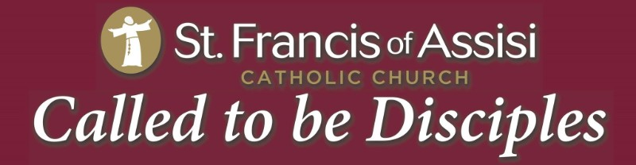

Religious Education Newsletter-March 2017
Our VBS theme has changed to:
“Maker Fun Factory”
“Created by God; Built for a Purpose!”

Ash Wednesday is next Wednesday, March 1st
- ^{6:30am- Prayer Service}
- ^{8:45am- Mass}
- ^{5:00pm- Prayer Service}
- ^{7:30pm- Mass}
- ^{8:30pm- Spanish Mass}
*Ashes will only be distributed during the above listed services, NOT in between
^{Services.}

Ash Wednesday

VBS Theme
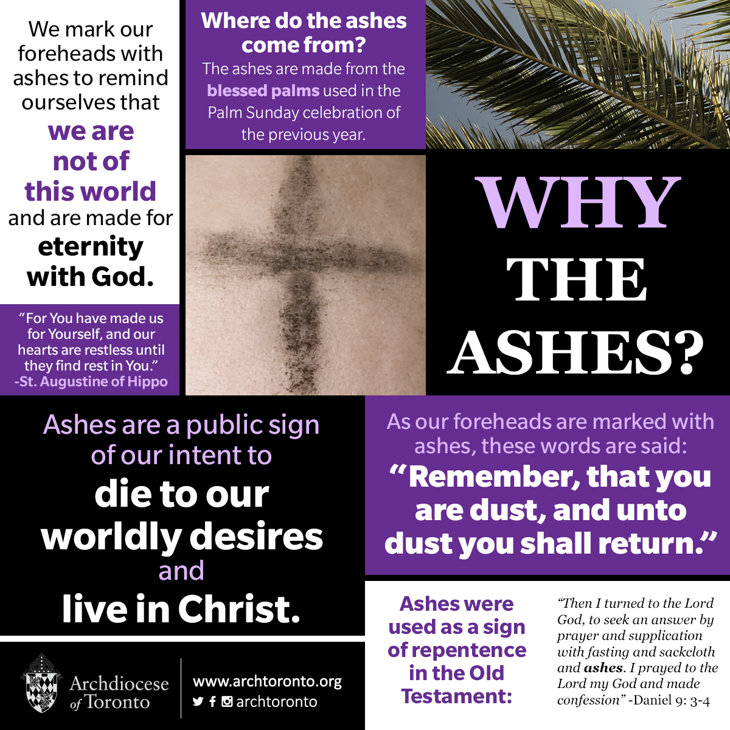

VBS Needs You!

We are in need of adult volunteers for VBS! Even though it is not until June we need to start planning! We will have VBS on June 19th -23rd. Many hands are needed to make this week possible for 160 kids! Volunteer form on our website at stfrncis.org for more information contact Sharon Gardner gardners.vbs@gmail.com

***RE Calendar is also on the website at stfrncis.org/learn/welcome introduction
Mar 2nd – RE- Lenten Prayer Service
Mar 4th – First Reconciliation
Mar 5th – RE- Lenten Prayer Service
Mar 9th – RE
Mar 12th- RE
Mar 16th – RE
Mar 19th- RE
Mar 19th- Special Olympics Basketball
Game- 2pm-5:15pm
Mar 23rd- RE
Mar 26th – RE
Mar 28th – Family Faith Formation Night (Lent) **Sign up with sign up genius on website, email will go out with link 6:30pm-8:30pm, limited availability.

****March 30th RE for Thursday classes

RE Calendar

Lenten Schedule

Ash Wednesday is the start of Lent. Children are not expected to fast from food but they can fast from certain comforts to give to the poor. Every year we support CRS Rice Bowl. This week your child will bring home a rice bowl to fill during Lent, please make it meaningful for them by making them earn the donation either by chores or by giving up a fast food meal, movie etc. Please return the rice bowls at the end of Lent to the RE Office. Many families across the world benefit from this charity

Almsgiving First Reconciliation
First Reconciliation for second graders and SPII is on Saturday, March 4th

9AM- St. Francis School, Homeschool

11:00AM- Sunday 4PM RE
Thursday RE

Upcoming Events for March in Parish
As part of our Family Faith Formation Night on March 28th we will be making
“Love Packs” for the homeless. Please donate to this worthy cause. Complete list of items attached to this email. Thank you

March 1st – Ash Wednesday
March 2nd & 5th RE Lenten Prayer Service
March 3rd – Holy Hour after 8:45am Mass
March 3rd- Soup and Stations begin- 6pm
March 10th & 11th – Men’s Cornerstone Retreat
March 12th-14th – Lenten Parish Mission
March 19th – Special Olympics Basketball Game
March 24th-25th- Women’s Cornerstone Retreat
March 28th- Family Faith Formation Night

Confession Schedule:
Every Wednesday during Lent- 7:30PM-8:30PM
Saturdays- 4:00PM-5:00PM
Soup and Stations- Every Friday starting March 3rd
Soup in the Dining Facility at 6:00PM and
Stations in the Church at 7:00PM
First Friday- March 3rd Holy Hour after 8:45AM Mass

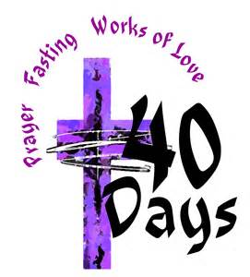

Lenten Schedule
Communication
Please contact Marianne Hayes at recoor@stfrncis.org with any absences, questions, concerns or Sheila Noble at snoble@stfrncis.org
All RE, Sacramental, VBS forms are on our website at stfrncis.org
Join our parish newsletter, form found on the homepage of our website
RE is on Pinterest! Under Saint Francis Religious Education

