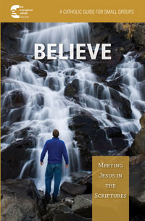 HOST INSTRUCTIONS

Thank you for hosting! The most important thing you can do is something you’ve already done – open your home and heart to this experience. The rest is easy!

- Please register by clicking on the Register to Host button on the webpage http://www.stfrncis.org/small-groups/ which ensures you will receive a complimentary copy of the guide. Host guides will be available in envelopes in the parish office for pick up during office hours, beginning Saturday, February 16th.
- Pick a day of the week and time for your group to meet. It is recommended that the study begin the week of March 3rd to comfortably complete the six weeks prior to Holy Week and Easter, but it is completely up to you and your schedule.
- Invite friends, neighbors, colleagues and/or people you would like to get to know (optimal group size is 4-10.) Participants do not need to be parishioners of St. Francis of Assisi or Catholic.
- Please let participants know they have the option of purchasing a copy of the study (digital or paper) through Amazon or Word Among Us. A button with a link to Word Among Us is on the webpage http://www.stfrncis.org/small-groups/.
- Food and drink are optional and up to each host’s discretion.
- Each session is designed to last approximately one hour, and it is up to the Host to decide whether or not to run longer.
- Please help us to track the program’s success and communicate with participants by having one person from each household provide you with an email address and cell phone number at the first meeting. Please provide this contact list to Lisa Ostendorf lostendorf@stfrncis.org after the first meeting. Thank you!
- The guide is simple to use. For your own ease, please familiarize yourself with the layout for a few minutes before the first session.
- If you have questions, please email Lisa Ostendorf lostendorf@stfrncis.org or call Lisa at the office Monday - Thursday 703-221-3127 ext. 277.

